**SERVO MOTORS**

**What is Servo Motor?**

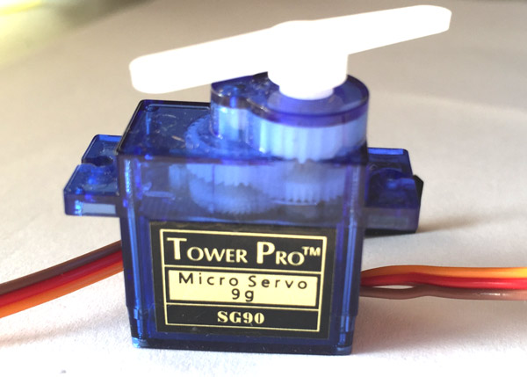This is a rotatory actuator which allows precise control of angular position, velocity and acceleration. It is better than DC motor because it provides more control to the user than DC motors and here the angle to which it is to be rotated can be controlled by user. Servo motors basically contain a DC motor but with gear box, control circuit and potentiometer which provides the additional control than a normal DC motor.

How does a Servo Motor work?

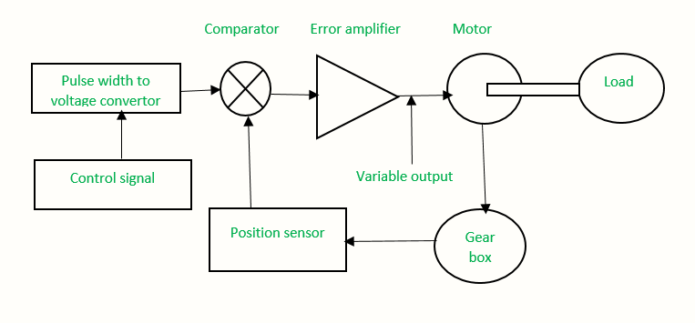

The control signal is produced by the micro-controller. The control signal is actually a PWM signal which is generated according to the angle of rotation given by user. Now, the PWM signal is given to voltage converter which produces an equivalent DC voltage. In the converter, the capacitor starts charging when the pulse is high and when the pulse is low, the charge on the capacitor discharges and is fed to the comparator. The position sensor comprising of potentiometer returns an absolute voltage of the motor shaft using the gear mechanism. Then this feedback voltage is also fed to the comparator. The comparator then compares the voltage related to current position of the motor with desired voltage related to desired position of the motor and produces the error voltage which is either a positive or negative voltage. Then this error voltage is amplified depending upon the operating voltage range of DC motor. The motor rotates till the error becomes zero.

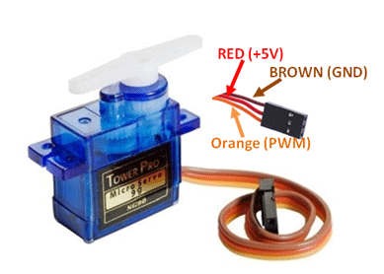**Wire Configuration**

|  |  |  |
| --- | --- | --- |
| **Wire Color** | **Name** | **Description** |
| Orange | PWM | PWM signal from microcontroller is supplied through this pin |
| Red | 5V | Powers the motor usually +5V DC is supplied |
| Brown | Ground | Connected to ground |

**Some more Specification**

|  |  |
| --- | --- |
| Operating Voltage | 4.8V-6.5V(commonly 5V is used) |
| Torque | 2.5kg/cm |
| Operating Speed | 0.1s/60° |
| Rotation Range | 0-180° |

**Controlling the Servo Motor**

The servo motor is controlled using PWM signals. The PWM signal supplied should be 20ms(50Hz) and should have a duty cycle between 1-2ms usually but it can vary. 1ms duty cycle creates a 0° rotation while 2ms duty cycle creates a 180° rotation.

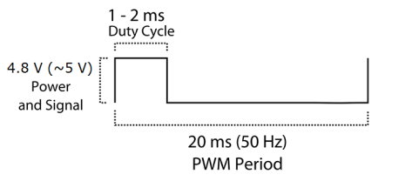

The Servo motor when controlled with Arduino, its code can be written using Servo.h library or one can also manually code the PWM signals. Both the ways are represented in the code files.